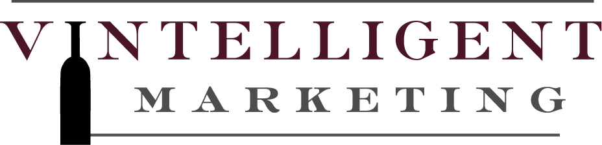

Phone 707-987-9821 FAX 707-987-0833
www.vintelligentmarketing.com

CONTACT: Valerie Moberg (707) 987-9821

FOR IMMEDIATE RELEASE

March 2, 2016

Vintelligent Marketing Expands Team with Addition of Sara Soergel

Napa Valley, CA – Established wine industry marketing firm Vintelligent Marketing, which celebrates its ten-year anniversary this year, announced today the addition of wine country native Sara Soergel to their team. The expansion of the Vintelligent Marketing team is the product of their success and diversification over the past decade, and positions them for continued growth in the wine industry.

Vintelligent Marketing, founded in 2006 by husband and wife duo Dan and Valerie Moberg, was created to combine and utilize the couple's extensive wine industry knowledge, including their wholesale, retail and direct-to-consumer wine sales experience, to help small and mid-sized wineries compete in an increasingly competitive market. After ten successful years, Vintelligent Marketing is excited to expand their reach with a larger and more diverse team. As Daniel summarized, "We are at a point now where we've proven ourselves in the industry, and we're ready to take our business to the next level. Sara brings a new energy, as well as a new set of skills and experience."

Their new team member, Sara Soergel, will work alongside Dan and Valerie to support Vintelligent's growing client roster, which includes the Rutherford Dust Society, Bevan Cellars, Thirty-Seven Wines, Davis Estates, One True Vine, and Pfendler Vineyards, among others throughout Sonoma County and the Napa Valley. Additionally, as co-executive directors of the Rutherford Dust Society, Daniel and Valerie also support the annual Day in the Dust media and trade tasting, the May Rutherford Wine Experience consumer event, and a series of additional industry and community events throughout the year. As Valerie explained, "Sara will be our right-hand person, supporting all of our clients, and is key to our expansion now and in the next ten years."

The daughter of a wine businessman and wife of a winemaker, Sara is excited to be marrying her professional background in marketing and creative services with her lifelong passion for the wine industry. Prior to joining Vintelligent Marketing, Sara was the head of accounts for a top creative agency in Santa Rosa, California and worked with key national and international accounts including Medtronic and Chevron, as well as local accounts like Sonoma State University and Central Valley. Upon taking the new position, Sara reflected, "As a native of this area, I am proud to be working alongside our region’s growers, vintners and wine industry entrepreneurs. The passion and enthusiasm for the wine industry is unmatched elsewhere, and it's an honor to be a part of this wonderful industry. I feel extremely grateful for the opportunity with Vintelligent Marketing."
- more –

RELEASE: Vintelligent Marketing Expands Team with Addition of Sara Soergel
RELEASE DATE: March 2, 2016
Page 2 of 2

About Vintelligent Marketing
Vintelligent Marketing was established in 2006 by the husband and wife team, Dan and Valerie Moberg. They specialize in helping small wineries focus their pricing, packaging and brand image to increase their market exposure and sales. For almost a decade, Vintelligent Marketing has built upon their industry connections and extensive professional experience in marketing, branding and wholesale, retail, direct-to-consumer wine sales, to help small and mid-sized wineries stand out in an increasingly competitive industry. For more information visit www.vintelligentmarketing.com.
###
*A Microsoft Word copy of this press release can be found at www.vintelligentmarketing.com

